Site Map

**Project—Assorted Games** \bootstrap-css bootstrap, bootstrap.min, bootstrap-theme, bootstrap-theme.min

bootstrap-js boostrap, bootstrap.min

**css** main00.css, main01.css, main02.css, main03.css, main04.css, main09.css, main99.css

**images**  **all_cards** 71 .jpg card images (52 cards, 13 jokers, 6 card backs)

dice images of die

**icons**  4 .jpg images (social media)

**other**  11 .jpg assorted images

special_deck special deck of young ladies in swimsuits

wheelimages 36 + images of roulette wheels

**javascript** jspage01.js (for video poker page only)

jspage03.js (for roulette page only)

jspage04.js (for backcraps only)

jspage99999.js (page for keeping extra javascript code)

00index.htm index page Lists which allows selecting other 8 pages (completed)

01poker.htm Video poker game (completed)

02blackjack.htm Blackjack game (under development)

03roulette.htm Roulette game (under development)

04bankcraps.htm Bank Craps game (under development)

05option5.htm Demolition Roller Derby game (suggested)

06option6.htm Mack Truck Chicken Challenge game (suggested)

07option7.htm AD&D: The Day of Judgement (dummy page)

08option8.htm The Inferno (dummy page)

09about.htm About Page (completed)

Site Map Diagram

Images

wheel-

images

dice

special_

deck

all_cards

icons

other

Javascript

jspage01

jspage03

jspage04

slides

00Index.htm

01poker.htm

02blackjack.htm

03roulette.htm

05option5.htm

04bankcraps.htm

06option6.htm

07option7.htm

08option8.htm

09about.htm

CSS

main00.cs

main01.cs

main02.cs main99.cs

main03.cs

main04.cs

main09.cs

Site Map Control Flows

00index

01poker.

02blackjack

03roulette

05option5

04bankcraps

06option6

07option7

08option8

09about

Arrows indicate control flow dictated by the user between the web pages.

HTML Page: 00index

Title is in larger font and centered.

All links are in large type, underlined, and change color when the mouse hovers over them. Clicking one sends the user to the desired selection.

The copyright notice is a bogus one.

Title

Link to first page in website

Link to second page in website

Link to third page in website

Link to fourth page in website

Link to fifth page in website

Link to sixth page in website

Link to seventh page in website

Link to eighth page in website

Link to ‘about’ page in website

Copyright Notice

HTML Page: 01poker

Title is in larger font and centered.

Current cards are shown in the five display slots.

The checkboxes allow discarding unwanted cards in the first round.

The four columned panel in the middle left shows possible hands and their payoffs. In one is achieved, the hand and its payoff is highlighted.

The message screen indicates the player’s hand. The earnings screen shows the earnings in the current session.

The colored buttons allow the player to control the game.

Return to Main Menu (centered) is the return link to the Main Menu.

The copyright notice (centered) is bogus.

Title

Return to Main Menu Page

Copyright Notice

**Card 1 Display**

**(card image)**

**Card 2 Display**

**(card image)**

**Card 3 Display**

**(card image)**

**Card 4 Display**

**(card image)**

**Card 5 Display**

**(card image)**

Checkbox 1

Checkbox 2

Checkbox 3

Checkbox 4

Checkbox 5

message screen

(white)

earnings screen

(white with a positive balance, red with a negative one)

Discard indicated cards button

Start button

Start Again button

Change Amount of Bet button

Possible Hands

panel 1

Possible Hands

panel 3

Payoff

panel 2

Payoff

panel 4

HTML Page: 02blackjack

\

Title is in larger font and centered.

Dealer’s cards (initially only two with one displayed) are shown in first two of the top seven slots as they are dealt.

The message screen displays information as needed.

The earnings screen shows the earnings in the current session.

The two sets of scores are display to the right side.

The player’s cards (two initially, both displayed) are shown in the bottom seven slots as needed.

The colored buttons allow the player to control the game.

Return to Main Menu (centered) is the return link to the Main Menu.

The copyright notice (centered) is bogus.

Title

Return to Main Menu Page

Copyright Notice

Message

Dealer’s additional Card

(card image)

Dealer’s first Card

(card image)

Dealer’s second Card

(card image)

Dealer’s additional Card

(card image)

Dealer’s additional Card

(card image)

Dealer’s additional Card

(card image)

Dealer’s additional Card

(card image)

Player’s additional Card

(card image)

Player’s first Card

(card image)

Player’s second Card

(card image)

Player’s additional Card

(card image)

Player’s additional Card

(card image)

Player’s additional Card

(card image)

Player’s additional Card

(card image)

$.00

Dealer’s Score

00

00

Player’s Score

Earnings

**Restart**

**Hit button**

**Stand**

**Split**

**Change bet**

**Play Again**

**Double Down**

HTML Page: 03roulette

Title is in large font and centered.

Roulette wheel spins constantly clockwise; the tiny ball, when released, rolls counter clockwise.

The Possibilities chart indicates betting options.

The roulette chart on the right allows the placement of bets. The player selects one and is prompted for the amount. Bets may be cleared individually or by clicking the Clear all Bets button.

When the Release Ball button is clicked, the ball appears and eventually lands in a slot. Its number on the chart turns yellow. Winning bets are paid; lost ones are collected.

The message screen provides prompts, indicates the wheel’s result and whether win(s) have occurred. The earnings screen shows the earnings in the current session.

Return to Main Menu (centered) is the return link to the Main Menu.

The copyright notice (centered) is bogus.

Title

Return to Main Menu Page

Copyright Notice

Possibilities

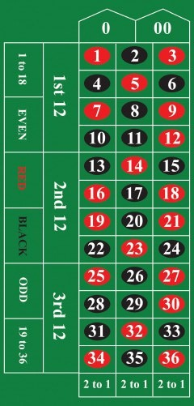

Message Area

Clear all Bets

Release Ball

**Restart**

Earnings

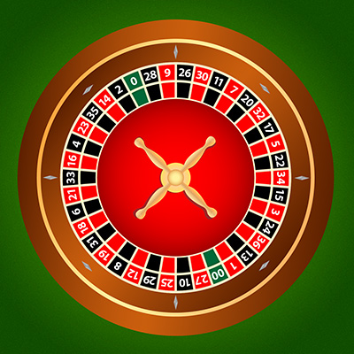

Winnings

HTML Page: 04bankcraps

Title is in larger font and centered.

The diagram is used for placing bets. Any dark blue area is a clickable button to place a bet. Its odds are located adjacent to the button. Each time the player clicks a button, he/she is prompted for the bet’s amount.

The dice (dark red) showing two ones are located at bottom center. Clicking the ‘Roll Dice’ button causes the images to change until a final dice outcome is achieved.

The ‘Clear all Bets’ button performs the named function. The Restart begins a new betting session. The area below the ‘Winnings’ label indicates the current session’s earnings.

Below the dollar amounts are any pertinent messages.

Return to Main Menu (centered) is the return link to the Main Menu.

The copyright notice (centered) is bogus.

Title

Return to Main Menu Page

Copyright Notice

**3**

**4**

**5**

**6**

**8**

**9**

**10**

**15-1**

**8-1**

**7-1**

**6-1**

**7-1**

**8-1**

**15-1**

**12**

**2 - 1**

**2**

**2 - 1**

**Field**

**Pays 1 -1**

**4**

**5**

**6**

**8**

**10**

**10**

**9**

**8**

**6**

**5**

**4**

**3**

**15-1**

**8-1**

**7-1**

**6-1**

**7-1**

**8-1**

**15-1**

**12**

**2 - 1**

**2**

**2 - 1**

**Field**

**Pays 1 -1**

**4**

**5**

**6**

**8**

**10**

Selected Doubles

30 - 1

**2**

**4**

**6**

**8**

**10**

**12**

30 - 1

15 - 1

**11**

15 - 1

6 - 1

**Doubles**

6 - 1

6 - 1

**Lucky 7**

6 - 1

7- 1

**Craps**

**2, 3, 12**

7- 1



Roll Dice

Clear all Bets

Restart

**Winnings**

**Message**

$0.00

$0.00

ToTotal All Bets Placed

HTML Page: 05option5

HTML Page: 06option6

HTML Page: 07option7

HTML Page: 08option8

HTML Page: 09about

Title is in larger font and centered.

Return to Main Menu (centered) is the return link to the Main Menu.

The copyright notice (centered) is bogus.

Title1

Title2

Copyright Notice

Return to Main Menu

Personal Photo

Personal information

Line 1

Line 2

Line 3

Line 4

Line 5

Line 6

Line 7

Line 8

Line 9